DIS-AM,C-Costa Rica-Figure-800-1200 A.D.

Costa Rica-Figure-800 - 1200 A.D.

Seated male figure with hands to his chest; tiara headdress; polychrome details painted in vibrant colors with orange and attractive dark umber line work on a white cream colored slip over a brown terra cotta ceramic. Intact no repairs. Excellent condition. Height: 7-1/8 in. (18cm).

Ex Zeus Gallery, *C.O.A.*

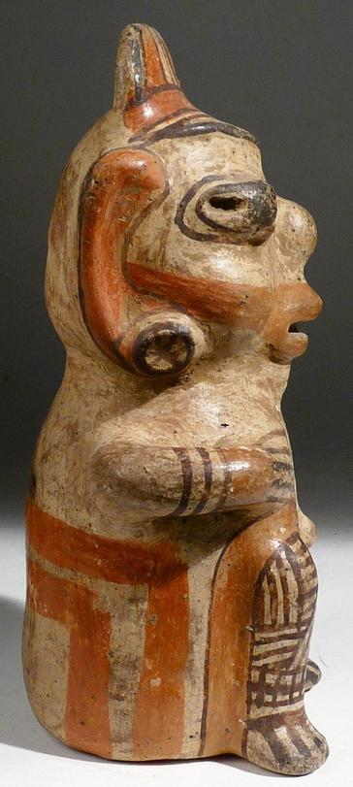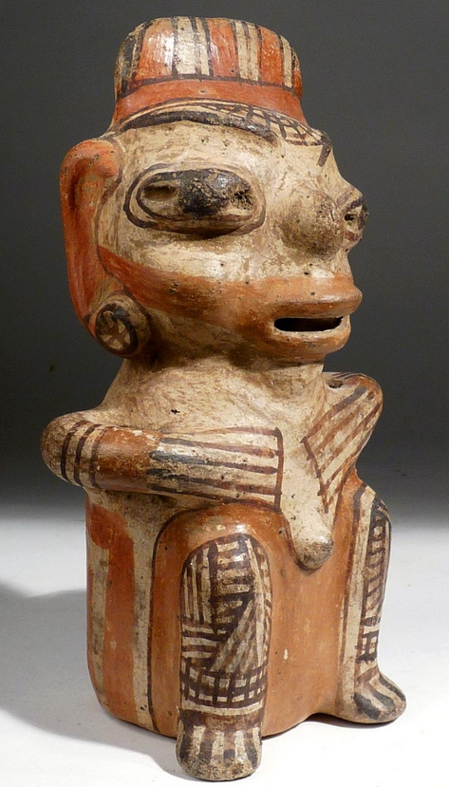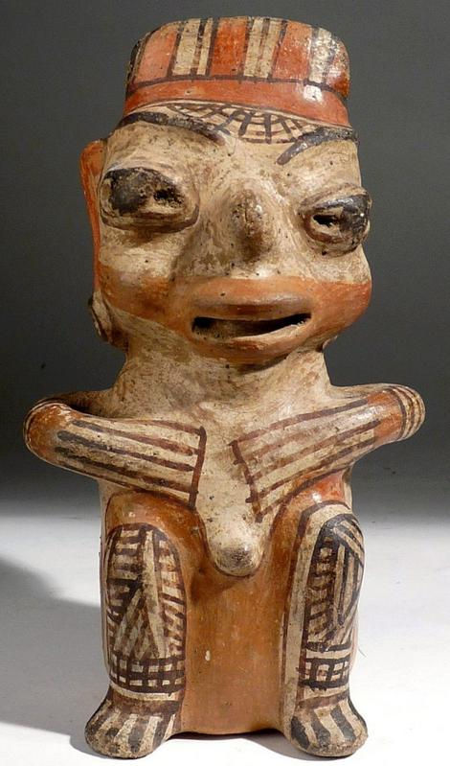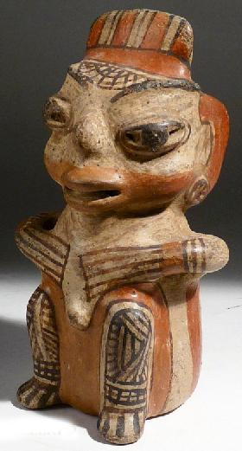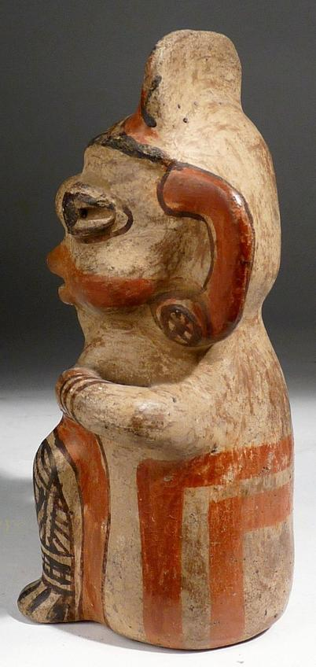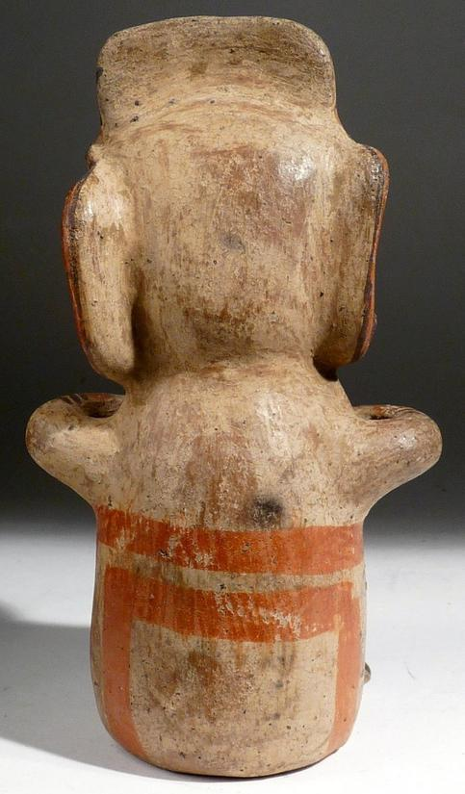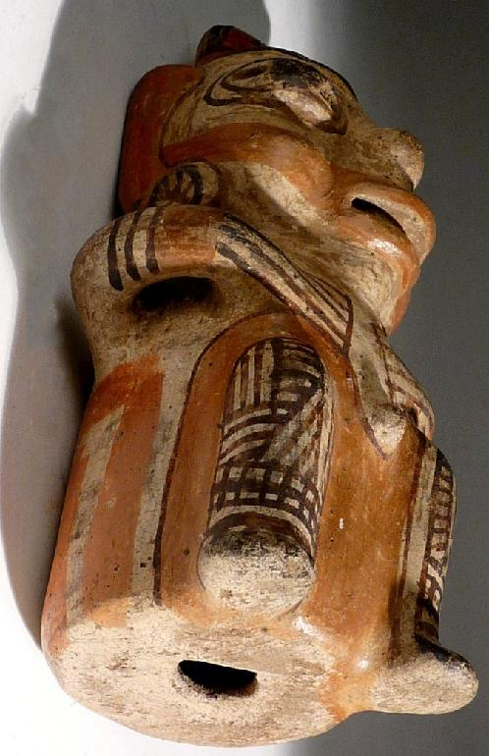

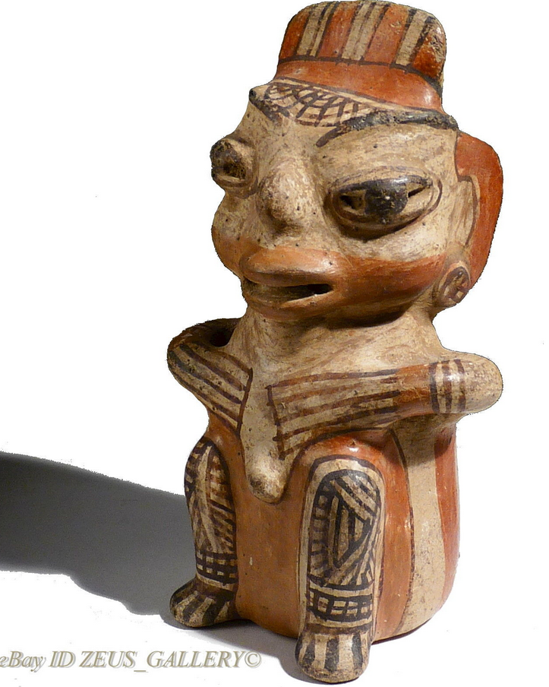

*All illustrations are of the actual item offered. The authenticity of all pieces is fully guaranteed. Lifetime Guarantee of Authenticity--Any item* ***ever*** *shown otherwise may be returned unaltered for full refund less shipping.   Also, if item purchased is not to your satisfaction you may return it unaltered within 30 days of purchase for a full refund less shipping. We also guarantee absolute discretion and confidentiality in all transactions.*